Game Proposal

Market Analysis
The marketing department and/or a market research firm, assuming your company can afford it, should compile this information. If you are compiling this information yourself, you should try to avoid pure guesses on numbers. Look for info on the Internet (http://www.gamestats.com/ is a good source) and use existing hits in the same genre as indicators for market performance.

Target Market
The target market is defined by the genre and the platform, issues that have been already addressed in the concept document. You can qualify this definition by mentioning specific titles that epitomize this market. The most successful of these titles will indicate the viability and size of the market. Also mention the typical age range, gender, and any other key characteristics. If this game involves a licensed property or is a sequel, describe the existing market.

Top Performers
List the top performers in the market. Express their sales numbers in terms of units, breaking out any notable data-disk numbers and any successful sequels. Include their ship date. You can be vague -- Q1 1998 or spring 1998. This research can go way back, so present your data in chronological order.
List their platforms if they vary from the platform for the proposed game. However, because the markets change depending on the platform, you should always present some title of the same genre on the target platform, even if it didn't perform as well as the others. Such data may indicate sluggishness for that particular genre of games on the platform. For example, turn-based strategy games may have great sales on the PC platform, but have terrible numbers on the Sony PlayStation. This list of top performers should indicate this discrepancy if you're doing a turn-based strategy game.

Feature Comparison
Break down the selling features of these top performers. Compare and contrast them to the key features described in the concept document. Try to provide some specifics. For example:
Tactical Combat: In Command & Conquer, Dark Reign, and Myth, you order your units to attack specific targets and move to specific places or ranges for an advantage. Most units have a unique strength and weakness that become apparent during play, thus encouraging you to develop superior tactics. Tanktics has a wider variety of orders to allow you to apply superior tactics, such as capture, ram, and hit-and-run. Unit position and target selection become even more important due to terrain, movement, and range bonuses; firing arcs; and soft spots in rear- and side-hit locations. All of the units have distinct weaponry, armour, and speed to differentiate their strengths and weaknesses and encourage tactics. Not only do you learn to master these tactics over time, but you can also script these tactics into custom orders.

Technical Analysis
The technical analysis should be written by a seasoned programmer, preferably the technical director or a lead programmer, and then edited and compiled into the proposal. Reviewers of this proposal will use this technical analysis to help them make their decisions. Be honest; it will save you a lot of grief in the end. Overall, this analysis should make the reviewers optimistic about the game's chance of succeeding.

Experimental Features
Identify the features in the design that seem experimental in nature, such as untried or unproven technologies, techniques, perspectives, or other unique ideas. Do not include features that have been proven by existing games, even if they are new to the development team. For example, if the team has never developed a 3D engine, don't list it as experimental. Rather, list it in one or more of the other categories in the technical analysis section. On the other hand, if your development team is working on a 3D engine using the theoretical system of quads, then this effort should be listed as experimental. Of course, by the time you read this article, quads could be in common use.
Include an estimate of the time that it will take to bring the experimental feature to an evaluation state, as well as an overall time estimate for completing the feature. Experimental areas generally need more time in the schedule, so the more experimental features you list, the longer the schedule will be. While some companies shy away from such 18- to 24-month projects, many see these experiments as worthwhile investments in creating leading-edge titles. So tell it like it is, but don't forget to tell them what they will get out of it. Make them feel comfortable that the experiments will work out well.

Major Development Tasks
In a paragraph or a few bullet points, make clear the major development tasks. Use language that non-technical people can understand. “Major” means months of development. Give a time estimate that assumes that you have all of the resources that you'll need to accomplish the task. You could also give an estimate of the resources that you'll need. For example:
Artificial Intelligence Script Parser: Three to four months with two programmers. The parser reads and compiles the AI scripts into lower-level logic and instructions that are executed at run-time.

Risks
List any technical risks. If you don't foresee any technical risks, by all means say so. Risks are any aspect of research and development that will cause a major set back (weeks or months) if they fail. List technologies that, though they've been proven to work by competitors, your company has never developed or with which your company has little experience. List, for example, real-time strategy if your team has never developed a real-time strategy game before; or 3D rendering if this is your first foray into 3D. List any of the major development tasks mentioned previously if you perceive any risk. All untried off-the-shelf solutions (3D engines, editors, code libraries and APIs, drivers, and so on) should be listed as risks because they may end up not fulfilling your particular needs. Any development done by an outside contractor should also be listed, as that's always a big risk.
When assessing risks, you should also indicate the likely impact that fixing or replacing the technology will have on the schedule. Indicate the time in weeks or months that the ship date will slip. List the time impact on specific resources. List any new resources (people, software, hardware, and so on) that would be required to fix it. This section may seem pessimistic, but it creates a comfort level for your document's reviewers - they will come away with the impression that the game implementation is under control, especially if they can perceive these risks themselves. Plus you'll have the opportunity to say, "You can't say I didn't warn you."

Alternatives
Alternatives are suggestions for working around some of these experimental or risky features and major development tasks. By presenting alternatives, you give the reviewers options and let them make the choices. List anything that might cost more money or time than desired but might have better results, or vice versa (it may cost less money and time but it may have less desirable results). Whatever you do, be sure to spell out the pros and cons.

Estimated Resources
List the estimated resources: employees, contractors, software, hardware, and so on. Use generic, industry-standard titles for people outside of the company: for instance, the publisher or investor who might read your document. List their time estimates in work months or weeks. Ignore actual costs (dollars), as that comes later.

Estimated Schedule
The schedule is an overall duration of the development cycle followed by milestone estimates, starting with the earliest possible start date, then alpha, beta, and gold master.

Legal Analysis
If this game involves copyrights, trademarks, licensing agreements, or other contracts that could incur some fees, litigation costs, acknowledgments, or restrictions, then list them here. Don't bother mentioning the necessity of copyrighting the game's title or logo, as these are par for the course and likely to change anyway.

Cost and Revenue Projections
The cost and revenue projections can be done in conjunction with the finance and purchasing departments. This data should give the reader a rough estimate of resource costs based on the technical analysis's estimated resources.

Resource Costs
Resource cost is based on the estimated resources within the technical analysis. Employee costs should be based on salaries and overhead, which the finance or payroll department should provide. You can list these as average by title or level. Any hardware or software that you purchase should be listed as well, even if it will ultimately be shared by other projects or folded into the overhead budget. Use a table or embedded spreadsheet as it is easier to read and edit. For example:
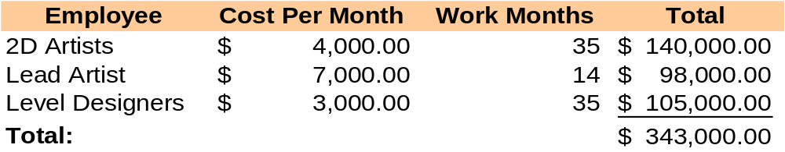
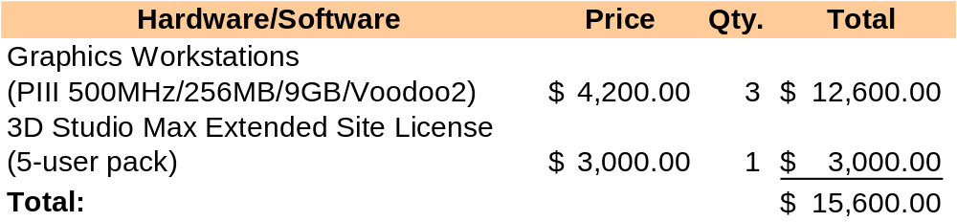

Additional Costs
This section is an assessment of additional costs incurred from licensing, contracting, out-source testing, and so on.

Suggested Retail Price
You should recommend a target retail price before your game goes in the bargain bin - pray that it does not. The price should be based on the price of existing games and an assessment of the overall value being built into the product and the money being spent to develop and manufacture it. Of course, your distributors will likely push for a lower sticker price or work some deals to use your game in a promotion that will cut the price even further, but that will all be ironed out later. Keep in mind that the higher the sticker price, the lower your sales, especially in a competitive genre where there's not as much demand as supply.

Revenue Projection
The revenue projection should show pessimistic, expected, and optimistic sales figures using the costs that you've already outlined and the suggested retail price. Other factors, such as marketing dollars and company overhead, should be left out of the picture as these are subject to change; if a minimum marketing budget is known, however, then you should certainly factor it in. Often the revenue projection is best represented with a pie chart or a bar chart. Be sure to indicate with an additional wedge or bar the costs incurred from any of the risks described in the technical evaluation and show totals with and without the risk assessment.

Concept Art
If your game concept did not include any art, then the game proposal certainly should. The art should be created by skilled artists. Dispose of or replace any of the art in the concept document that was not created by the artists. The art will set the tone for the game. Assume that the readers may only look at the art to evaluate the proposal, so be sure that it expresses the feel and purpose of the game. Include a number of character, unit, building, and weapon sketches, in both color and black and white. Action shots are great. Include a GUI mock-up if your game is a cockpit simulation. Be sure to have good cover art. Paste some of the art into the pages of the documents, as it helps get your points across and makes the documents look impressive.

